Authors:

Group 28

Minjuan Luo - 20313326

Krishi Madipelly - 19334112

Jonathan Kelly - 20335359

Deirdre Luo - 20332191

1. **Background Research Undertaken**

**Introduction to System:**

· A local sports club – A domain that offers services to the members of the sports club

· A domain for a sports club offers members to

o Access the timetable for upcoming matches

o Contact the people who run the club (Secretary, Treasurer)

o Register for the club (Pay in full\instalments)

**How we went about researching the domain:**

· We researched different sports clubs websites online. (eg. [www.molaise.ie](http://www.molaise.ie/))

· We researched different books and articles that contained use cases + activity diagrams (eg. UML in Practise book).

· We researched what services a local sports club domain would usually provide (eg. Registering online for a membership.)

· We researched the different ethical considerations needed for a local sports club (the privacy of the members personal information, the protection of financial information when transactions occur)

**How we went about undertaking the task:**

· We downloaded VScode and used ‘.drawio’ to draw the activity diagrams.

· We used Blackboard Collaborate to communicate with each other and exchange ideas.

· We used an iPad to draw the Use Case Diagrams

· We all met in person to discuss the project.

---------------------------------------------------------------------------------------------------------------------------

1. **Description of Ethical Consideration for your system (using Ethics Canvas)**

**Ethics in the Sports Club**

* **Social and Legal Layer**
  + Norms
    - Code of Ethics for the Club – Must be adhered to by all members
  + Legislation
    - Insurance Documents
      * **PLAYER INJURY SCHEMES AND INSURANCE**
    - Privacy Policies
      * GDPR
  + Regulation
    - Regulation from the National Committee for the given sport (eg. The GAA regulates sports such as Gaelic and Hurling etc.)
    - Providing rules and norms that a club must follow
* **Ethical Layer**
  + Principles
    - Respect for coaches, staff and players.
* **Technical Layer**
  + Data Governance / Standards
    - Protecting personal data of the members of the club
    - Providing software that can safely transfer money in the club (eg. The protection of credit card details when paying for annual membership online.)

**Ethics in a Technology Development Project**

* **Project Goals**
  + To provide a website which can serve the needs of a local sports club
    - Allowing the members to join the club via. the website
    - Allowing members to see an online timetable for upcoming matches and fundraiser events
    - Allowing people to access important documents surrounding the club policies and legal matter
    - Giving members the ability to contact the club (eg. To be able to send emails to the club secretary)
    - Giving members access to an online shop where the club sports gear can be bought
* **Legal Constraints**
  + GDPR
  + GAA regulation
* **Ethical Position**
  + Safeguarding privacy of members

**Considerations on Ethical Impacts of Technology**

Relationships between individuals

* Between high ranking members of the club (eg. Treasurer and club owners)

Relationships between individuals and collectives

* Between the GAA and the Club Committee

Impact of technology failure

* If the website is hacked and personal data of the members gets exposed

**Ethics Canvas**

**Trinity College Dublin,** The University of Dublin

19

Stage 1: Identify the Relevant Stakeholders

* **Individuals:** Who use your product or service?
  + **Adult members**
  + Children **(**less likely to use the website**)**
  + People outside the club who are either
    - Interested in joining
    - Playing against the club in an upcoming game
* **Groups:** Which groups are involved in the design, production, distribution and use of your product or service?
  + - * Web designers and people who do website maintenance
      * The club committee
      * Web hosting services (eg. Hostgator)
      * The company that provides the web domain (eg. GoDaddy)
      * Sponsors

Stage 2: Identifying Ethical Impacts

‘Micro’ Impacts

* **Behaviour**: How might people’s behaviour change because of your product or service?
  + Less reliance on “word of mouth” to get info. on club activities
  + Less reliance on the use of cash to pay for membership and club clothing (payments can be done online using card)
  + More online messaging will take place
  + People will be perceived to be available 24/7 via. Online messaging rather than on a 9-5 basis
* **Relations:** How might relations between people and groups change?
  + Relations between players and club committee might weaken since the players will not have to interact face to face with them (as most services will be provided by the website)

‘Macro’ Impacts

* How might people’s Worldviews be affected by your product or service?
  + Personal phone numbers of club committee members no longer considered ‘private’
* Social conflicts: How might **Group Conflict** arise or be affected?
  + Potential conflict between players and coaches through messaging services
* Potential negative impact of your **product or service failure**?

* + If communication channel fails then there is a loss of critical communication between members of the club
  + Data hacks can leak personal info. of club members
* Potential negative impacts of the **consumption of resources** relating to your project?
  + Loss of control over a large list of phone numbers / email addresses

Stage 3: How to Address Ethical Impacts

* Attain adequate servers that can store large amounts of personal data.
* Ensure the adequate code of ethics and guidelines are in place so conflicts on online messaging services don’t arise.
* Have the proper software in place that can protect against hackers
* Transparency and control over sharing and use of phone contact list

----------------------------------------------------------------------------------------------------------------------

1. **Eight fully described UML Use Cases (ovals)**

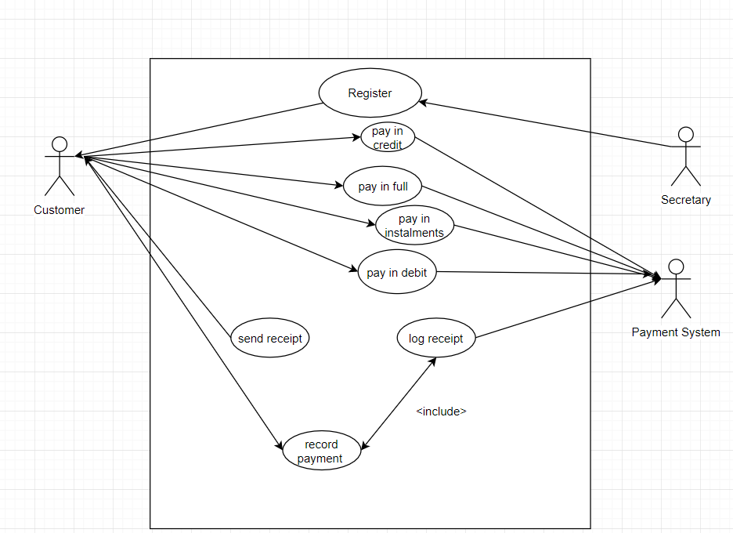

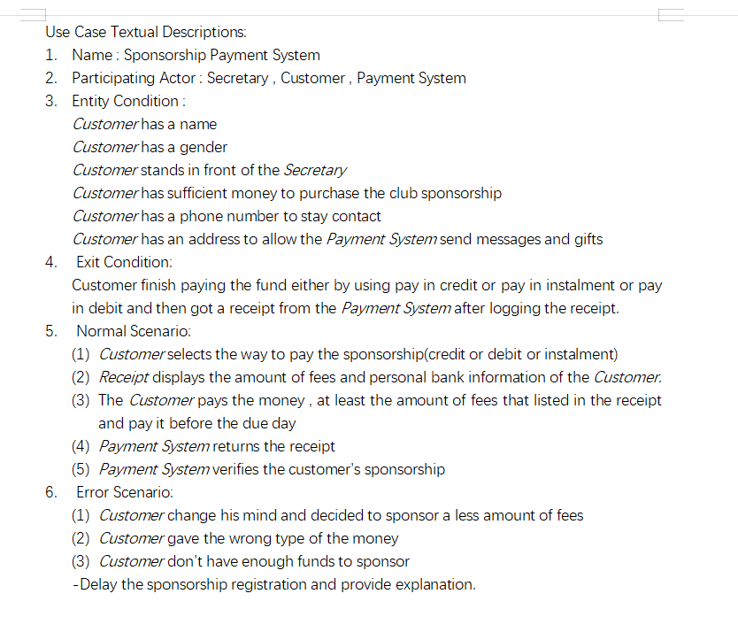

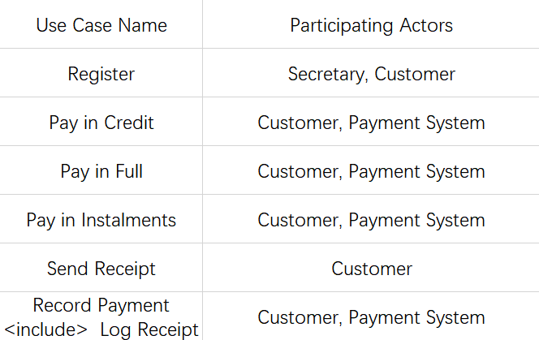

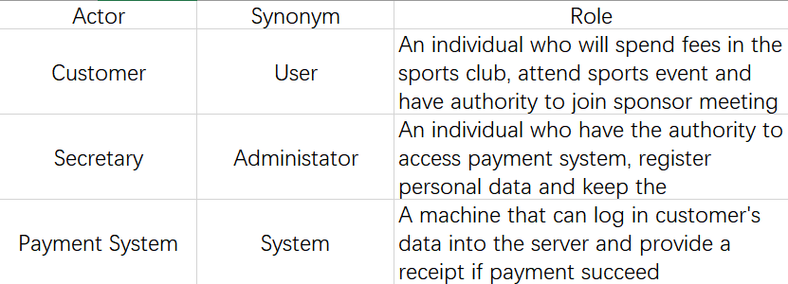

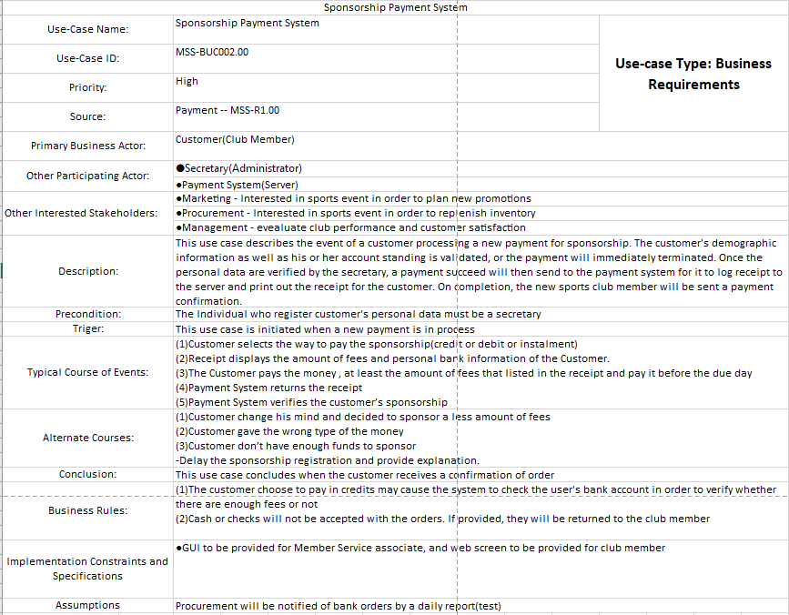

----------------------------------------------------------------------------------------------

1. **A UML Class diagram comprising: at least 15 classes with each class having at least 2 data attributes**

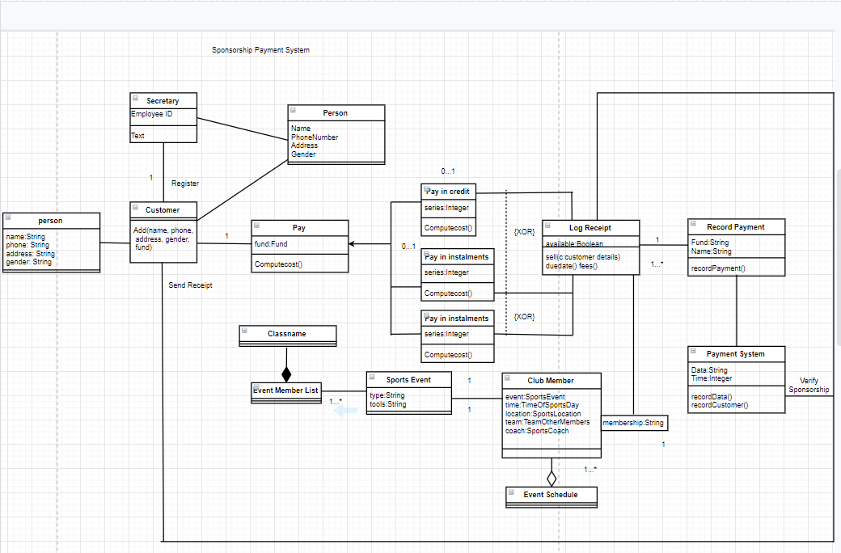

-------------------------------------------------------------------------------------------

1. **Two detailed UML Activity diagrams with descriptions for two selected use cases/ovals.**

Activity Diagram for Paying for membership in sports club:

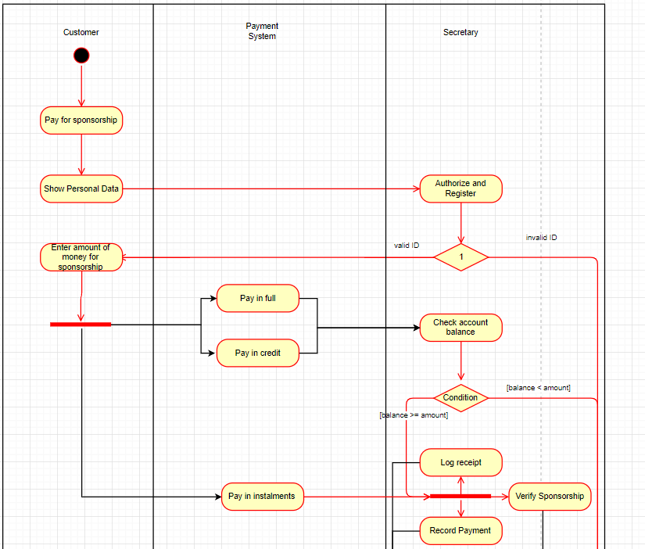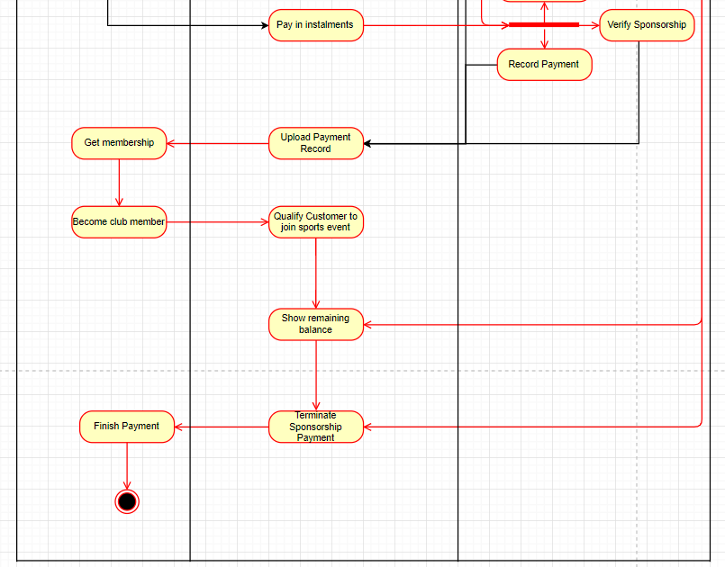

Sequence diagram for the registration process:

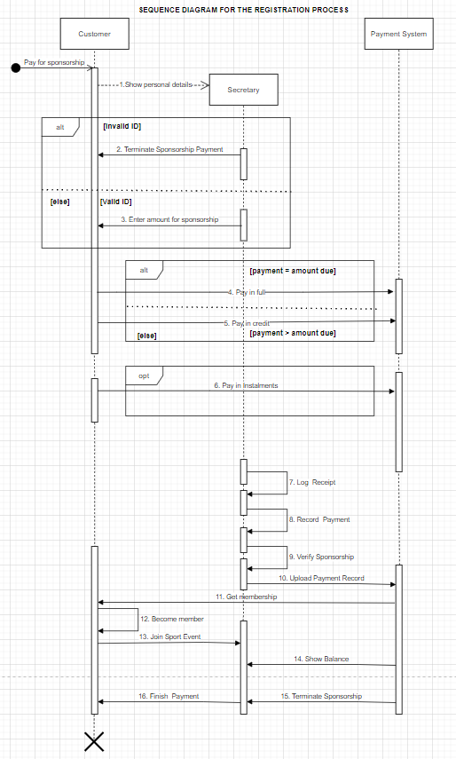

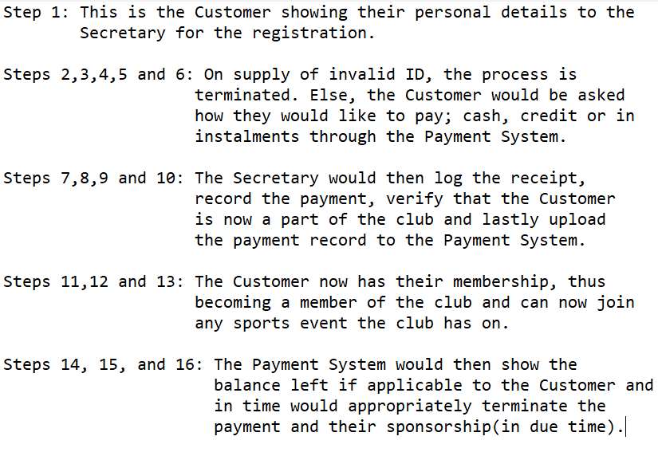

-----------------------------------------------------------------------------------------

1. **Listing of who did what**

**Deirdre**

o Researched different Use Cases

o Researched different examples of online sport club websites

o Drew up the Use Cases

o Downloaded the relevant software to draw the Use Cases

· **Minjuan**

o Downloaded the relevant software to draw the activity diagrams

o Drew out the activity diagrams

o Wrote out the Class diagrams

o Researched different examples of activity and class diagrams.

· **Krishi**

o Researched different Sequence Diagrams

o Drew out the sequence diagrams and downloaded the relevant software to do so.

o Researched different examples of online sports club websites

· **Jonathan**

o Researched the ethics involved in running a sports club website and the different legal factors that are taken into consideration.

o Drew out the ethics canvas.

o Researched different examples of sports club websites.

-------------------------------------------------------------------------------------

1. **Discussion of Strengths and Weaknesses of the overall UML Design**

Strengths:

* System is designed to react to different scenarios (eg. The system can react to an “error scenario” like when the customer can’t pay for the membership)
* The Use Case is very easy to understand the relationships and communications involved in the sports club.
* The text descriptions help the reader comprehend the components of the UML Design.
* The layout of the UML Design is fundamentally simple to implement.
* The system covers the whole procedure of a customer who wants to participate in the sports club event and even be a core member of the club, which makes people easily understand what they are gonna do. That can motivate people to come and join the club.
* The Activity Diagram easily shows the interaction between different actors, which makes it easier to understand what the programmers are gonna do and how to program every step of the work.

Weaknesses:

* Sequence and Activity diagrams are both complex which both need to be explained in order to be understood.
* The Class Diagram contains many components, which makes the diagram hard to read.
* The Activity Diagram does not make explicit which object is executing which activity.
* The Use Case Diagram can show the whole process with one single page, but causing the page really messy with lines and ovals, which makes the diagram hard to read
* Although the system that we drew considered a lot of situations and scenarios, there still were many error scenarios that we didn’t think about. A system with vulnerabilities may cause a great failure when running a program.